Warning - PHEV_FHEV_BEV_Ready – PHEV_FHEV_BEV – CGEA1.3

Functional Description

The instrument cluster shall illuminate the ready indication based on the input from the HPCM or PCM via the GWM PwPckTqRdy_B_Dsply signal on the CAN bus. This STSS is covering the PHEV, FHEV and BEV.

Per 07 Nov 2013 DI Change Control direction is to display Ready To Drive warning message upon powerpack start up until the vehicle is shifted into a drivable gear or is cleared by the operator.

This STSS covers only automatic transmission applications. If in the future a PHEV, FHEV or BEV is introduced with a manual transmission then this STSS will have to be updated.

The requirements for China market are regulatory per GB/T 4094.2-2005. Previously, M.12 symbol was used for Non-China markets and the symbol “READY” (tbd.95) was used for China market for notification. This China market strategy is now adopted globally and M.12 symbol will be discontinued.

This STSS is obsoleted based on direction for EPE team.

Interfaces

Interface Context Diagram (I/O Block Diagram)
PHEV_FHEV_BEV_Ready Warning

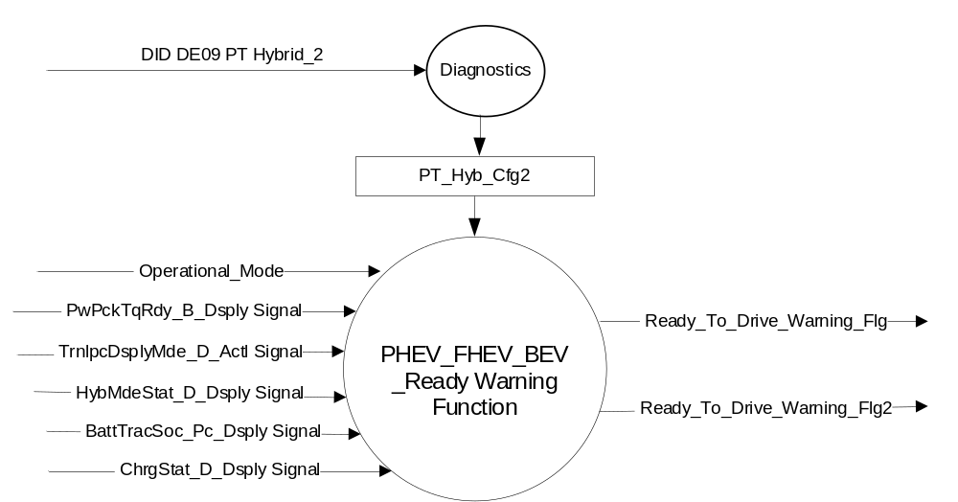

Inputs

IR-REQ-322782/A-INTERNAL:

- Operational_Mode

MUX Signals on CAN bus

SIG-REQ-322769/A-PwPckTqRdy_B_Dsply Signal Details

Signal Name | Size (bits) | Detail | Units | Res. | Offset | State Encoded | Min | Max
PwPckTqRdy_B_Dsply | 1 |  | SED | 1 | 0 |  | 0 (0x0) | 1 (0x1)
 |  | Off |  |  |  | 0x0
 |  | On |  |  |  | 0x1

SIG-REQ-322770/A-TrnIpcDsplyMde_D_Actl Signal

Signal Name | Size (bits) | Detail | Units | Res. | Offset | State  Encoded | Min | Max
TrnIpcDsplyMde_D_Actl | 3 |  | SED | 1 | 0 |  | 0 (0x0) | 7 (0x7)
 |  | Park |  |  |  | 0x0
 |  | Reverse |  |  |  | 0x1
 |  | Neutral |  |  |  | 0x2
 |  | Drive |  |  |  | 0x3
 |  | Sport |  |  |  | 0x4
 |  | Manual_1_Low |  |  |  | 0x5
 |  | Manual_2 |  |  |  | 0x6
 |  | Manual_3 |  |  |  | 0x7

SIG-REQ-322771/A-HybMdeStat_D_Dsply Signal

Signal Name | Size (bits) | Detail | Units | Res. | Offset | State Encoded | Min | Max
HybMdeStat_D_Dsply | 3 |  | SED | 1 | 0 |  | 0  (0x0) | 5  (0x5)
 |  | Null State |  |  |  | 0x0
 |  | Auto Charge Deplete Mode |  |  |  | 0x1
 |  | Auto Charge Sustain Mode |  |  |  | 0x2
 |  | Forced Charge Sustain Mode |  |  |  | 0x3
 |  | Forced EV Mode |  |  |  | 0x4
 |  | EV_Override |  |  |  | 0x5
 |  | Not Used |  |  |  | 0x6
 |  | Not Used |  |  |  | 0x7

SIG-REQ-322772/A-BattTracSoc_Pc_Dsply Signal

Signal Name | Size (bits) | Detail | Units | Res. | Offset | State Encoded | Min | Max
BattTracSoc_Pc_Dsply | 8 |  | Percent | 0.5 | 0 |  | 0  (0x0) | 100  (0xC8)

SIG-REQ-322773/A-ChrgStat_D_Dsply Signal

Signal Name | Size (bits) | Detail | Units | Res. | Offset | State  Encoded | Min | Max
ChrgStat_D_Dsply | 3 |  | SED | 1 | 0 |  | 0 (0x0) | 7 (0x7)
 |  | Not Ready (Null State) |  |  |  | 0x0
 |  | Fault - Unknown Location |  |  |  | 0x1
 |  | Fault Inside Car |  |  |  | 0x2
 |  | Fault Outside Car |  |  |  | 0x3
 |  | In progress |  |  |  | 0x4
 |  | Scheduled |  |  |  | 0x5
 |  | Complete |  |  |  | 0x6
 |  | Not Used |  |  |  | 0x7

Outputs

IR-REQ-322783/B-INTERNAL:

- Ready_To_Drive_Warning_Flg
- Ready_To_Drive_Warning_Flg2 (this display adds the “XXX% Charged” text)

Function/Performance

F-REQ-322786/A-Operational Modes

Mode | Differentiating Vehicle Conditions
Sleep Mode | “Ready to Drive” Warning is off
Limited Mode | “Ready to Drive” Warning is off
Normal Mode | “Ready to Drive” Warning is on/off
Crank Mode | “Ready to Drive” Warning is on/off

Voltage Levels

Refer to the Cluster Features table located in the Operational Modes and Voltage Range Strategies section in this SPSS

Human-Machine Interface

Visual

Indicator Graphics / Display Format

Legacy Graphics
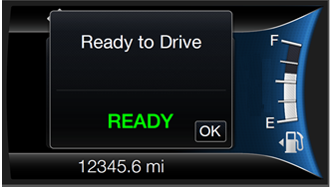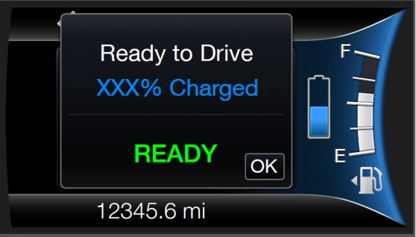
W3350a W3353a

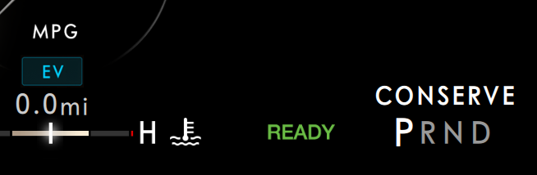
- Refer to the Model(s) and specific graphics delivery for the exact indication & display Graphics

Indicator Color Coordinates

- Refer to the COLOR & ILLUMINATION REQUIREMENTS (GRAPHICS) of the Master SPSS File

Indicator Characteristics

- Refer to the specific graphics/animation for timing and transitions.

Audio

None

Switch Control Logic

Not Applicable.

PFM-REQ-322787/A-System Accuracy

- The message should be re-displayed on subsequent ignition key transitions to the start position if the ready indication command is true.

Operation: Performance and Functional

Subsystem Algorithm Flowchart / State Diagram

F-REQ-322774/B-Ignition Status Handling Routine
None

F-REQ-322775/B-“Ready to Drive” Set Active Warning Flowchart
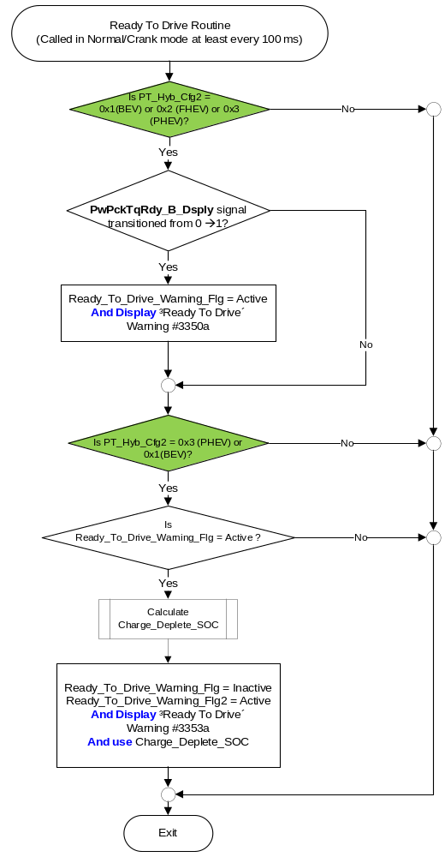

Design Note for Figure above (Not a requirement, but an FYI for understanding):
We do not guarantee that the HPCM will always broadcast at least one value of PwPckTqRdy_B_Dsply = 0 in key run/start prior to sending a value of 1. The solution is to either monitor for this transition any time the bus is awake (i.e. in all key cycles), or to initialize the signal to 0 on transition from OFF/ACC to RUN/START. We chose the latter.

F-REQ-322776/B-Calculate Charge_Deplete_SOC for percentage display
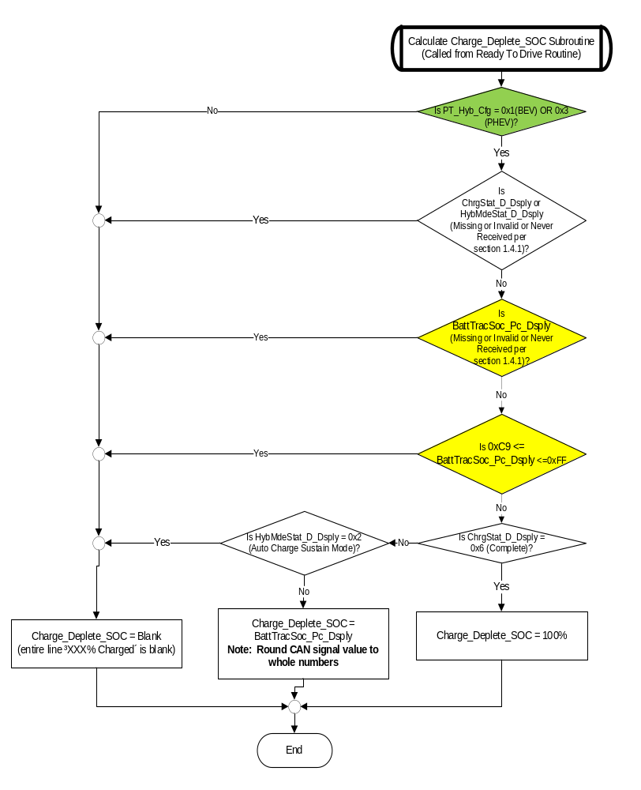

F-REQ-322777/A-Ready_To_Drive_Warning_Flg Set Inactive Flowchart

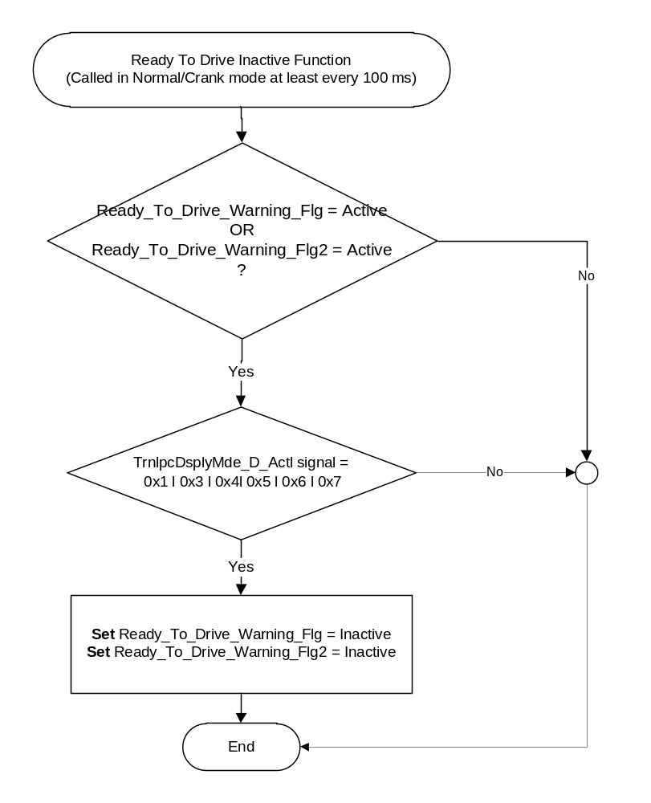

Operation Description (supports algorithm flowchart /state diagram)

F-REQ-322778/A-“Ready To Drive” Active Warning Flag

“Ready To Drive”  Active Warning Flags | Warning # Displayed
Ready_To_Drive_Warning_Flg | W3350a
Ready_To_Drive_Warning_Flg2 | W3353a

F-REQ-322779/B-HPCM_Wakeup_Delay_Timer
No More Applicable

FS-REQ-322788/A;1-Function Safety Classification (EMC)

B

Memory Storage

NVM-REQ-322780/A-Parameter Storage

Parameter Name | Description | Value at  Battery Connect | Value at  Module Wake-up | Value at  Transition to Normal/Crank Mode From Limited Mode
Operational_Mode | 4 state indicator for cluster operational mode | Limited | Limited, Normal or Crank | Limited, Normal or Crank
PwPckTqRdy_B_Dsply Signal | CAN signal sent from GWM for “Ready to Drive” State | 0x0 | 0x0 | 0x0
TrnIpcDsplyMde_D_Actl | Transmission mode for display on instrument cluster. CAN signal from PCM | 0x0 | 0x0 | 0x0
Ready_To_Drive_Warning_Flg | Used to control the “Ready to Drive” with “READY” text Warning state | Inactive | Inactive | Inactive
Ready_To_Drive_Warning_Flg2 | Used to control the “Ready to Drive” with “READY” text & “XXX% Charged” Warning state | Inactive | Inactive | Inactive

NVM-REQ-322781/B-Timer Storage:
None

Prove Out

No

Reconfigurable Telltale

None

Error Handling

Missing Message Strategy

CAN signals will be declared missing as per the Diagnostics section of this SPSS.

DTCs states and history will be determined as per the Diagnostics section of this SPSS.

Diagnostics

Self Test

None

Engineering Test Mode

None

Part II Performance

DTC-REQ-322784/A-Supported Diagnostic Trouble Codes (DTCs)

DTC | Description
C29300 for HPCM | Lost Communication with HPCM

DCR-REQ-322785/B-DID DEXX

Block  Num | Block Description | Size (bits) |  | Byte(s) | Bits | State: Description | Default | Comments/  Information
PACKETED BLOCKS
$09 | Option Content (B&A) |  |  | * | 3 | PT Hybrid2(PT_Hyb_Cfg2)  0x0 = Non-Hybrid  0x1 = BEV  0x2 = FHEV  0x3 = PHEV  0x4 = MHEV | 0x0 = Non-Hybrid | Default from cluster plant to be 0x0 if cluster can be used on a Non-Hybrid.

Reference Specification
IS-0001 WARNINGS/INDICATORS/DISPLAYS PROVEOUT
IS-0052 OPERATING VOLTAGES - FUNCTIONAL/PERFORMANCE
IS-0069 FUNCTIONAL IMPORTANCE CLASS
IS-0324 WINDSHIELD & OTHER REFLECTIONS
IS-0327 WARNING INDICATOR EVALUATION
IS-0379 NORTH AMERICAN WARNINGS AND INDICATORS STRATEGY

IL-0017 TELLTALE AND INTERIOR ILLUMINATION – COLOR AND INTENSITY
IL-0019 GENERAL ILLUMINATION DIMMING
IL-0021 CRAFTSMANSHIP – DISPLAYS
IL-0022 GENERAL ILLUMINTATION COLOR
IL-0023 CLARITY/LEGIBILITY/READABILITY/VISUAL CONTRAST
IL -0043 OPERATIONAL ENVIRONMENT FUNCTIONALITY
IL -0045 COLOR
IL -0047 TELLTALE, INDICATOR AND DISPLAY LIGHT INTENSITY
IL -0048 ILLUMINATION ACCEPTABILITY

03-0661 PLACEMENT: CONTROL AND DISPLAY LOCATIONS
03-0662 PLACEMENT: LOGICAL GROUPING FUNCTION AND USAGE
03-0664 PLACEMENT: DOWN VISION TO COMPONENTS WITH HIGH VISUAL DEMAND
03-0665 PLACEMENT: EXPECTED LOCATIONS OF CONTROLS AND DISPLAYS VDS
03-0670 INTERIOR VISIBILITY
03-0671 INTERIOR VISIBILITY: REFLECTIONS FROM COMPONENTS & SURFACES
03-0672 INTERIOR VISIBILITY: REFLECTIONS IN DISPLAYS
03-0673 INTERIOR VISIBILITY: VISUAL OBSCURATIONS
03-0674 INTERIOR VISIBILITY: ILLUMINATION CONTROLS / DISPLAYS
03-0675 INTERIOR VISIBILITY: VEILING GLARE
03-0677 INTERIOR VISIBILITY: SUNLIGHT WASHOUT
03-0681 IDENTIFICATION: CHARACTER AND SYMBOL SIZE
03-0682 IDENTIFICATION: LEGIBILITY
03-0685 IDENTIFICATION: SYMBOLS, ABBREV FOR CONTROL
03-0721 LOGIC OF OPERATION: OPERATIONAL STEREOTYPES
03-0722 LOGIC OF OPERATION: INTERPRETATION
03-0723 LOGIC OF OPERATION: USE OF SYSTEMS WITH VISUAL DISPLAYS

Driver Information Display Control (DIDC), Version 3.8
Subsystem Specific Diagnostic Specification (Part 2) (GMRDB_*.xls – Refer Latest)
Diagnostic Fault Coverage and DTC Numbers Design Considerations (Document # 00.06.15.601)
DIDC Requirements for 16MY Electric Range HMI PHEV Change Requests_v03.3_2014_09_22

Revision History

STSS Module Revision History

Revision Level | Name | Change Description | Date
1.0 | M. Hakim | Initial Release | 2/4/2011
2.0 | S. Watkins  M. Hakim | Updated Document to apply to PHEV and FHEV only. This warning for BEV is handled in the Budget_Set_Ready STSS.  - Updated the document title in section 1.0 and in footer.  - Updated the functional description in section 1.1  - In section 1.5.3, removed the DTC for PCM for BEV  Updated the context diagram of figure 1 in section 1.2.1 to have one output only, Ready_To_Drive_Warning_Flg and updated outputs list in section 1.2.3 to reflect the correct output.  In section 1.3.1, changed the wording of “Indication & text message” to “Warning” and removed “based on PwPckTqRdy_B_Dsply value”  In section 1.3.3.1, updated the graphic and added the warning number  In section 1.3.5.1, replaced the state matrix table with a flowchart figure, which included the condition of transition of signal PwPckTqRdy_B_Dsply from 0 →1 and to include the W# 1810  Added “Ready To Drive” Active Warning Flag table, Table 2  In section 1.3.5.4:  - Updated the name of “Ready_to_Drive” to “Ready_To_Drive_Warning_Flg”  - Changed the value of PwPckTqRdy_B_Dsply signal at “Battery Connect” to 0x0  Updated the References in section 1.6 | 6/10/2011
3.0 | J.Blatchford | Intent of this revision is to change the Ready to Drive text from displaying for 4s upon powerpack transitioning to on to displaying until the vehicle is shifted into a drivable gear.  - 1.1: Added 4th and 5th paragraph.  - Figure 1: Added input signal.  - Table 1.1: Added table.  - 1.3.1: Changed warning to being displayed in Crank. If this changes existing function supplier to review with Ford.  - 1.3.3.1.1: Updated W#s.  - Figure2: Updated W#s. Removed statement that this routine is only called until PwPckTqRdy_B_Dsply transitions 0→1.  - Figure 3: Added Figure.  - Table 2: Updated W#s  - 1.3.5.4: Added signal to memory storage.  - 1.4.1: Added note relative to new signal. | 1/12/2014
4.0 | S. Watkins | As part of the MY16PHEV changes, the PHEV Ready to Drive warning shall now also show “XXX% Charged”. This is a PHEV only change. Since the warning is now unique between PHEV/FHEV added logic to handle both vehicles. Also, there is a delay before % charge can be determined, so that was added as well. STSS modifications were extensive, so no change highlights. Treat as new STSS.  This STSS also incorporates the China market requirements. There is “China – CD391C Specific” version 1.0 STSS that was merged into this STSS since this should be the primary STSS going forward. | 9/4/2014
5.0 | T. Cwik | Update for common graphics and to display the Warning without the HPCM timer delay. The delay is used only for the PHEV warnings that include the SOC value.  Section 1.1 – Updated last paragraph about China Market  Section 1.2.1 – Added Ready_To_Drive_Warning_Flg4  Section 1.2.3 – Added Ready_To_Drive_Warning_Flg3 and Ready_To_Drive_Warning_Flg4  Section 1.3.3.1.1 – Updated graphics for W3350a and added graphics for W3353a.  Section 1.3.5.1 –  – Figure 3 – Rewrote flowchart  – Figure 5 – Added Ready_To_Drive_Warning_Flg4 in Decision Diamond and Action Box  Section 1.3.5.2 – Table 1.5 00 Added Ready_To_Drive_Warning_Flg4 row  Section 1.3.5.4 – Added Ready_To_Drive_Warning_Flg4  Section 1.6 – Added #5 | 9/23/2014
5.1 | T. Cwik | Update to correct a logic error introduced with _v5.0.  Section 1.3.5.1 – Figure 3 – Added one Decision Diamond of “Is  Ready_To_Drive_Warning_Flg = Active OR Ready_To_Drive_Warning_Flg3 = Active ?” | 4/10/2015
5.2 | A. Venuturupalli  S. Watkins | Update to clarify BattTracSoc_Pc_Dsply Missing, Invalid, Never Received and out of valid range behavior  Figure 4 – Added two decision diamonds  Per Denso Q&A C34x MY16 #37 | 4/29/2015
5.3 | R. Chalanti | Updated a typo in Figure 3 for W#3353 msg | 6/8/2015
5.4 | R. Chalanti | Clean up of STSS to apply China flags for Global market. Removed unwanted flags and modified the following sections appropriately  Changes in Cyan  - Functional description modified  - Context diagram – Figure 1 – updated  - Section 1.2.2 – deleted End part Item Number input for China  - Section 1.3.3.1.1 – W3350 and W3353 messages and related Graphics Updated  - Figure 3 updated  - Figure 5 updated  - Table 1.5 modified to remove W3350, W3353 messages  - Section 1.3.5.4 Memory Storage is updated | 9/20/2016
5.5 | P.Denduku | Initial VSEM RM Release; Deleted Strikethrough text | 7/17/2018
5.6 | H. Sharma | This update is part of updates for new BEV program Cx727 and for future BEV programs. This STSS is updated from Warning - PHEV_FHEV_Ready - PHEV_FHEV - CGEA1.3_v5.4 to expend its scope and include BEV variation. Earlier this STSS was applicable only to PHEV and FHEV and this is also applicable to BEV. Changes from Baseline are marked in green color.  > HPCM_Wakeup_Delay_Timer removed from all the places.  > PT Hybrid1 is updated to PT Hybrid2  > Flow charts updated to add BEV configuration wherever applicable. | 01/31/2018
5.7 | H. Sharma | Obsolete | 10/04/19

